**Title:** Brand Loyalty among Millennial (Generation Y) and Generation Z

**Thesis Type:** written Assignment

**Student Name:** Lloyd Gitari Miriti

**Matriculation Number:** 9222479

**Course:** Master Finance and Accounting

**Instructor:** Tamara Wehrstein

**Date:** Submission Date

**Abstract**

The purpose of this study, which was carried out in Nairobi, Kenya, was to find out if Gen Z consumers are less brand loyal than Millennials. Additionally, the study looks at and contrasts the underlying mechanisms of the two generational groups that influence brand loyalty. It also investigates the notion that, in contrast to Millennials, Generation Z is more devoted to tech products. An online survey with closed-ended questions was used to gather data from 70 individuals in the sample population. The age range of the subjects needed for this study was between 21 and 43, which corresponds to the generational divide between Millennials and Generation Z.

Contents

1. Introduction 1

**1.2.** **Rationale for Subject Selection** 2

1.3. Aim and Objectives of the Assignment 2

1.3.1. Aim 2

1.3.2. Objectives 2

1.4. Topic Boundaries and Definitions 2

1.5. Keywords: Brand loyalty, Generation Z, Millennial 2

1.6. Outline of the Structure 3

2. Literature Review 3

2.1. Overview of Brand Loyalty 3

2.2. Role Played By Social Media and Influencers on Brand Loyalty 4

2.3. Generational Differences in Brand Loyalty 5

3. Theoretical Framework 6

3.1. Theory of Planned Behavior 6

3.2. Consumer Decision-Making Models 6

3.3. Technology Acceptance Model 6

4. Arguments and Counterarguments 6

4.1. Arguments for Lower Brand Loyalty in Generation Z 6

4.2. Counterarguments 6

5. Quantitative Survey Research Design 7

5.1. Survey Objectives 7

5.2. Research Questions 7

5.3. Methodology 7

5.3.1. Participants: 7

5.3.2. Data Collection: 8

5.3.3. Survey Questions: 8

6. Data Analysis 10

6.1. Statistical Analysis 10

6.1.1. Descriptive Statistics: 10

6.1.2. Comparative Analysis: 13

6.2. Discussion 14

6.2.1. Findings: 14

6.2.2. Limitations: 14

7. Conclusion 15

7.1 Summary of Key Arguments 15

7.2. Conclusion of the Thesis 15

7.3. Future Research 15

8. Bibliography 16

8.1. References 16

Table of figures

Figure 1 9

Figure 2 11

Figure 3 12

Figure 4 13

Figure 5 14

Figure 6 14

# Introduction

* 1. **Background**

One of the most important aspects of marketing is brand loyalty, which is the willingness of a customer to keep using or repurchase a brand's goods or services. Understanding the subtleties of brand loyalty among various generational cohorts—particularly millennials (Generation Y) and Generation Z—becomes essential as firms navigate a constantly changing market. These groups display unique behaviors and preferences that influence how loyal they are to brands and how businesses should adjust their marketing methods.

Social media is believed to be the main element affecting brand loyalty among millennials and Generation Z. There are facts that there are more than 5.5 billion social media users worldwide. Facebook, Instagram, X (formerly known as Twitter), Snapchat, Tinder, YouTube, LinkedIn, and Tiktok are some of these social networking sites. By 2024, it is estimated that social media advertising will bring in $250 billion in revenue.

It is estimated that 88% of millennials and Generation Z learn new information via social media. Additionally, data indicates that between 85% and 90% of millennials and between 90% and 95% of generation Z feel comfortable making purchases online. Because of the disparity in income between the two generations, millennials spend more money on products than generation Z. Data indicates that there is a rising trend in internet transactions throughout time.

Since Generation Z was reared mostly in the age of social media, brand loyalty is thought to have been greatly impacted. On the other hand, because they were somewhat shaped by social media, millennials are thought to have less of an impact. However, it is thought that Generation Z will continue to be faithful to electronic products like vehicles and smartphones, among other things, and that their allegiance to these items will not ultimately change. On the other hand, depending on the advantages the company offers, millennials will continue to be loyal to it. They place importance on a brand's satisfaction in terms of social standards, comfort, and health. According to popular belief, Generation Z remains devoted to products based on the feelings they arouse and the degree to which their demands are met among classism.

Brand loyalty is greatly influenced by social media influencers, or users with large followings. It is crucial for brands to advertise through influencers' channels because the majority of Generation Z and Millennials rarely watch television, read magazines, or read newspapers. Instead, they frequently spend a lot of time viewing content provided by these individuals.

* 1. **Rationale for Subject Selection**

Understanding brand loyalty across generations is essential to comprehending the behavior of modern consumers. It is crucial to investigate how social media's widespread effect and the quickening pace of technology advancements affect the disparities in brand loyalty between generations. In order to determine whether Generation Z is less brand loyal than Millennials, this study focuses on Millennials and Generation Z.

## Aim and Objectives of the Assignment

### Aim

This study intends to investigate and assess if Generation Z exhibits less brand loyalty than Millennials. To this end, a quantitative survey research design will be developed, current literature will be reviewed, and preliminary data will be analyzed to provide empirical insights.

### Objectives

* To comprehend what Millennials and Generation Z are all about?
* Be able to point out restrictions for additional research.
* To identify role played by social media and influencers in brand loyalty
* To identify how technology advancement affect brand loyalty
* To determine how factors affecting brand loyalty differ in both Millennials and Generation Z

## Topic Boundaries and Definitions

The comparison of Millennial and Generation Z brand loyalty habits will be the main focus of the analysis. Important terms like generational cohorts and brand loyalty will be clarified, and the study will only look at these two generations—no other generations or characteristics will be included. However, social media and influencers—two important variables—will be considered in defining brand loyalty among Millennials and Generation Z.

## Keywords: Brand loyalty, Generation Z, Millennial

## Outline of the Structure

- Introduction

- Literature Review

- Theoretical Framework

- Arguments and Counterarguments

- Quantitative Survey Research Design

- Vague Data Analysis

- Conclusion

# 2. Literature Review

## 2.1. Overview of Brand Loyalty

Brand loyalty is the propensity of consumers to consistently select one brand over another. According to research, it's important to understand how a range of factors, including emotional attachment, brand satisfaction, and perceived value, influence loyalty (Doe, 2020). Johnson and Brown (2021) and Smith (2022) dispute that brand loyalty is only dependent on consumer happiness. According to Moorman et al. (1993), factors like customer trust, customer commitment, and perceived service quality also have a big impact on customer loyalty. Major factors influencing customer loyalty are their sustained interest in the services provided and the high expense of moving to a different brand.

Actually, according to Kotler and Keller (2012), customer satisfaction is determined by the discrepancy between the client's expectations and perception following the provision of services. As a result, this fills in a gap in the order between expectations and the supplied services. The hypothesis that there are other variables influencing the two processes is intriguing in light of this. Kunde and Datta (2015) state that there are both emotional and rational reasons to consider when measuring contentment. Depending on the previous services, the client's perception may be favorable or unfavorable. A good business may generally be identified by its capacity to provide a seamless transaction procedure for the customer. Customers' input and actions can be used to analyze this process in its entirety, as they provide future needs, intents, and consumption patterns (Paquette, 2006).

Keep in mind that maintaining a steady client base is crucial for a firm to establish a reputation in the marketplace. According to Rust & Ming Hui (2014), this retention helps the business establish stability because the devoted consumers will go on to refer their proxies and friends to it. A firm is considered successful if the key elements influencing brand loyalty are maintained and the level of services is maintained. This leads us to compare the brand loyalty of Millennials with Generation Z, taking into account key aspects that impact brand loyalty. We will assess the distinctions between Gen Z and Millennials, look at the impact of trust, satisfaction, dedication, and perceived service quality, and ultimately draw some positive conclusions. This therefore breaks our hypothesis to;

**H0:** Generation Z have lower customer trust compared to Millennials

**H0:** Generation Z have lower customer commitment compared to Millennials

**H0:** Generation Z have lower customer satisfaction compared to Millennials

**H0:** Generation Z have expeditiously high perceived quality of services compared to Millennials

## 2.2. Role Played By Social Media and Influencers on Brand Loyalty

For Millennials and Generation Z, social media and influencers are now essential to maintaining brand loyalty. These digital channels allow for a different kind of consumer-brand connection that is unmatched by traditional media. Smith (2021) asserts that digital natives like Millennials and Gen Z mostly depend on social media for brand validation and discovery. Users can interact with brands in real-time on social media sites like Twitter, Instagram, and TikTok, which fosters a more dynamic and intimate relationship. In addition to raising brand awareness, this participation creates a feeling of community and belonging, both of which are important factors in building brand loyalty.

Influencers bridge the gap between brands and their target audiences, which is a crucial part of this dynamic. Brown and Hayes (2022) assert that influencers use their perceived authenticity and personal brands to gain followers' trust. Because Millennials and Gen Z consider influencers to be more personable and believable than traditional advertising personalities, this trust plays a critical role in influencing their purchasing decisions. Influencers that match their brands with beliefs and lifestyles that appeal to these younger populations can improve brand perception and increase consumer loyalty.

Furthermore, social media's participatory qualities boost the efficacy of influencer marketing. Millennials and Gen Z are more likely to interact with brands that use interactive content, such surveys, Q&A sessions, and live streaming, according to research by Kim and Ko (2023). Influencers are skilled at using these interactive technologies to produce interesting content that boosts user engagement and increases brand loyalty. Stronger brand loyalty results from this degree of engagement, which also raises the possibility of repeat purchases and improves the whole brand experience.

Lastly, statistics on consumer behavior provide even more credence to the role that influencers and social media play in building brand loyalty. Millennials and Gen Z who follow businesses and influencers on social media are more likely to show higher degrees of brand loyalty, according to a study by Lee and Li (2023). Increased exposure to brand messaging and the emotional bond created by ongoing interaction with influencers are blamed for this tendency. It is anticipated that these personalities and platforms will have an increasing impact on brand loyalty as they develop, which emphasizes the necessity for firms to proactively use influencer alliances and social media to create enduring consumer relationships.

This leads us to the next set of variables that have a significant impact on social media: influencers and the usage of social media. This strengthens our hypothesis, so

***Ho***: Compared to Millennials, Generation Z is more inclined to switch brands based on the influence of their favorite influencer.

***Ho***: Generation Z spend more time on social media platforms than Millennials

## 2.3. Generational Differences in Brand Loyalty

Millennials: Studies show that people born between 1981 and 1996—also known as Generation Y—displays a combination of traditional and digital consumer behaviors. They are swayed by peer recommendations and social proof, and they appreciate authenticity in brands. According to research by J., & Garton, C. (2013), Millennials are more inclined to stick with companies that share their values and provide individualized experiences.

Born between 1997 and 2012, Generation Z is the first generation to have lived exclusively in the digital age. They are distinguished by a strong propensity towards social media influence, a high degree of brand distrust, and a preference for immediate pleasure. According to research by (Koulopoulos & Keldsen, 2014), social media trends and influencer endorsements frequently influence Gen Z's brand loyalty.

Comparative Studies: Previous studies comparing Gen Z and Millennial brand loyalty have demonstrated that, despite appearing less brand-loyal in some circumstances, Gen Z brand loyalty manifests itself in a variety of ways, most notably through ethical consumption and brand advocacy (Koulopoulos & Keldsen, 2014).

# 3. Theoretical Framework

## 3.1. Theory of Planned Behavior

Ajzen (1991) created a hypothesis that looks at attitudes, perceived behavioral control, and subjective norms in order to explain brand loyalty. By utilizing this theory, one can investigate how the attitudes of Millennials and Generation Z towards businesses and their societal influences impact their brand loyalty.

## 3.2. Consumer Decision-Making Models

AIDA (Attention, Interest, Desire, and Action) and Loyalty Ladder models are two examples of models that shed light on how customers go from first brand awareness to steadfast devotion. It is possible to use these models to comprehend how various generations interact with companies.

## 3.3. Technology Acceptance Model

This model investigates the ways in which perceived utility and simplicity of use affect consumer behavior. Knowing how Gen Z and Millennials use digital platforms might help us better understand their brand loyalty practices.

# 4. Arguments and Counterarguments

## 4.1. Arguments for Lower Brand Loyalty in Generation Z

Media Influence: Brand flipping may rise as a result of Generation Z's continual exposure to social media platforms. According to studies by (Twenge, 2017), Gen Z is encouraged to often experiment with new businesses by social media's dynamic character.

Short Attention Span: As discussed by (Koulopoulos & Keldsen, 2014), the fast-paced digital world is thought to contribute to a shorter attention span and a preference for novelty over brand loyalty.

## 4.2. Counterarguments

Various Expressions of Loyalty: Melnyk's (2020) research suggests that although Gen Z may be more likely to transfer brands, they nevertheless demonstrate significant brand loyalty by endorsing and supporting companies that share their values.

Variations by Product Category: Gen Z's loyalty could differ depending on the type of product. For example, White (2018) observes that, in contrast to traditional consumer goods, Gen Z exhibits greater devotion to ethical businesses and technological brands.

# 5. Quantitative Survey Research Design

## 5.1. Survey Objectives

* To empirically assess whether Generation Z displays lower brand loyalty compared to Millennial.
* To access whether customer trust as a factor affecting brand loyalty is significantly lower in Generation Z compared to Millennials.
* To compare if customer commitment as a factor also affecting brand loyalty is low in Generation Z than in Millennials.
* To check how satisfied are Generation Z compared to Millennials after accessing services from a brand.
* To access how perception of products as a factor affecting brand loyalty compare in Generation Z to Millennials.
* Access place of social media and influencers on brand loyalty in comparison between Millennials and Generation Z.

## 5.2. Research Questions

* How does brand loyalty among Generation Z compare to that of Millennial?
* Do customer trust, customer commitment, customer satisfaction, and perceived quality of services affect brand loyalty? And if yes to what extent?
* How does customer commitment vary among Millennials and Generation Z?
* How does customer trust vary among Millennials and Generation Z?
* How does customer satisfaction vary among Millennials and Generation Z?
* How does perceived quality of services vary among Millennials and Generation Z?
* How do level of loyalty to tech objects among Generation Z compare to that of Millennials?
* What implications do social media and influencers have in the comparison of brand loyalty between Millennials and Generation Z?

## 5.3. Methodology

### 5.3.1. Participants:

A convenient sample of thirty-five individuals from each generation was selected. Nairobi, Kenya served as the survey's conducting city. The participants primarily fell within the 1981–2012 age range, which is where Generation Z and Millennials are ranked. Survey eligibility was denied to respondents who did not fall within this age range.

### 5.3.2. Data Collection:

The Kobo Collect surveys were distributed online via links shared in WhatsApp groups; additional surveys were distributed via emails, and all incomplete surveys were removed from the analysis. In all, 137 trials were conducted prior to reaching the desired 70 participants from both generations, as we encountered individuals who were not in the target age range and others who were unable to finish the survey.

### 5.3.3. Survey Questions:

The questionnaire asked questions about demographic criteria, namely; age, gender, occupation, and educational background. Determining how much time Generation Z and Millennials spend on social media each day piqued curiosity as well. This would make it easier to identify the member of the two generations most vulnerable to the effect of social media. Additionally, participants were asked to rate the likelihood that they would switch from one technical product to another. The Likert scale was used to rate the questionnaire on a range of 1 to 5. The highest level of agreement was represented by level one, while the largest amount of disagreement was represented by level five. As you proceeded down the scale, the level of agreement declined. In the table below are extra questions that necessitated in measuring brand loyalty and determining magnitude of factors affecting loyalty.

Figure 1

|  |  |
| --- | --- |
| Questionnaire: Brand Loyalty Among Generation Z and Millennials | |
| **Instructions:**  Please indicate your level of agreement with each statement by selecting the appropriate number on the scale: 1. Strongly Disagree, 2. Disagree, 3. Neutral, 4. Agree, and 5. Strongly agree. | |
| Customer Loyalty | 1. I tend to stick with the same brands even when new alternatives are available. 2. Once I find a brand I like, I rarely switch to other brands. 3. I am loyal to brands that I have used for a long time. 4. I would recommend my favorite brands to others without hesitation. 5. I often feel a strong connection to the brands I use. |
| Customer Trust | 1. I trust the brands I frequently purchase from to provide high-quality products/services. 2. I believe that the brands I am loyal to are honest and transparent in their communications. 3. I feel confident that the brands I support act in my best interest. 4. I am likely to continue using a brand even if it makes a mistake, as long as it resolves the issue. 5. I feel that my personal data is secure with the brands I use regularly. |
| Customer  Commitment | 1. I am willing to go out of my way to stay loyal to my preferred brands. 2. I actively follow and engage with my favorite brands on social media. 3. I am willing to pay more for a brand I trust. 4. I frequently provide feedback to brands to help them improve their products/services. 5. I participate in loyalty programs offered by the brands I am committed to. |
| Customer Satisfaction | 1. I am generally satisfied with the quality of the products/services provided by my preferred brands. 2. My experience with the customer service of the brands I use is positive. 3. The brands I am loyal to meet my expectations consistently. 4. I am satisfied with the value I receive from the brands I frequently purchase from. 5. I feel that my experiences with my preferred brands are worth the money spent |
| Perceived Quality | 1. The brands I trust provide products/services that I perceive as high quality. 2. I believe that the brands I use regularly are superior to competitors in terms of quality. 3. I think the quality of products/services from my preferred brands is consistent. 4. I perceive the brands I am loyal to as leaders in their industry. 5. The overall quality of my preferred brands justifies my loyalty. |
| Social Media and Influencers | 1. Social media influencers' opinions affect my choice of brands. 2. I am influenced by social media marketing when deciding on brands. 3. I often discover new brands through social media platforms. 4. My loyalty to a brand is strengthened by positive social media reviews and influencer endorsements. 5. I follow my favorite brands on social media to stay updated on their products/services. |

# 6. Data Analysis

## 6.1. Statistical Analysis

### 6.1.1. Descriptive Statistics:

Here I investigated the overview of the demographic factors and also the descriptive statistics of main variables.

Figure 2

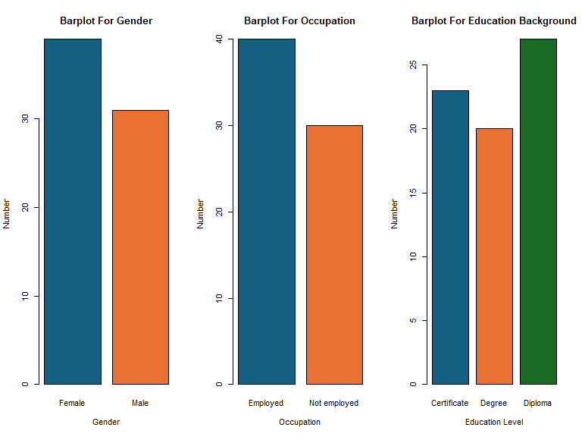

There were thirty men and forty women in the data. Thirty of the individuals were jobless, while forty were employed. As seen in fig. 2 above, 23 participants held certificates, 20 held degrees, and 27 held diplomas. The average age of the participants was 29.7 years, with 23.9 years for Generation Z and 35.5 years for Millennials.

Figure 3

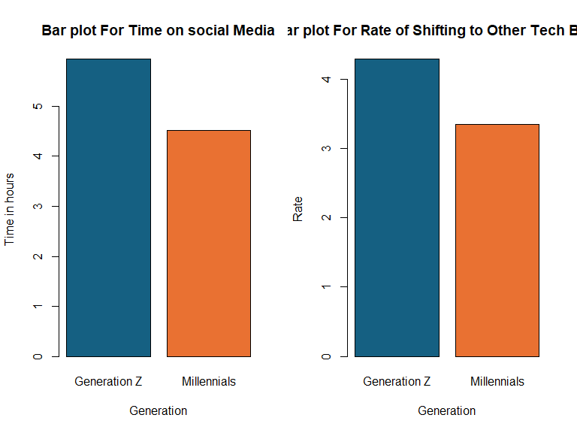

Figure 3 above shows that Millennials use social media less than Generation Z. Generation Z is more likely to be influenced by social media because they use it for an average of six hours a day compared to millennials' four and a half hours. When it came to switching to other tech items, millennials had a rate of 3.5, whilst Generation Z demonstrated a rate of 4. The Likert scale indicated that Millennials were likely to switch between different tech products.

Figure 4

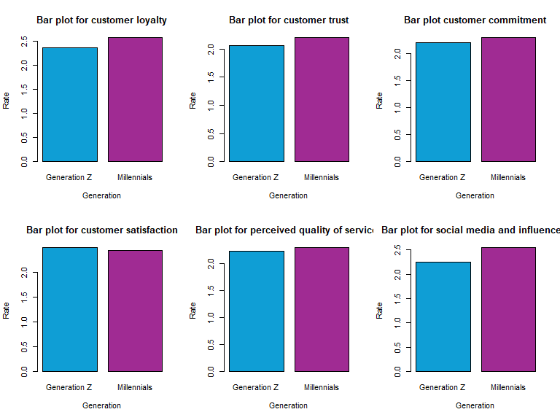

Figure 4 above presents descriptive comparisons instead of statistical comparisons. Wilcox's sign rank test will be used to verify the comparisons on the comparative analysis below. Customer loyalty among Generation Z was 2.371, whereas it was 2.571 among Millennials. Regarding customer trust, Millennials scored 2.200, whereas Generation Z scored 2.057. In terms of client loyalty, Generation Z showed a rate of 2.200, while Millennials showed a rate of 2.286. In terms of consumer satisfaction, Millennials scored 2.429, while Generation Z scored 2.486. Regarding the perceived quality of items, Millennials scored 2.286, whereas Generation Z scored 2.229.Lastly, Generation Z reported a rate of 2.257 under influencers and social media, whilst Millennials reported a score of 2.543. According to the descriptive statistics, Millennials have lower brand loyalty rates than Generation Z. This was also true for the elements that promote brand loyalty, such as commitment, social media, influencers, perceived product quality, and trust; yet, for satisfaction, the opposite was true.

### 6.1.2. Comparative Analysis:

According to descriptive comparisons, the two generations' degrees of brand loyalty differ, with Millennials exhibiting greater variety in their loyalty practices. I used a Wilcox's sign rank test in my comparison study to see whether there were any significant differences. Because the data was not normally distributed, I employed Wilcox's sign rank test.

Figure 5

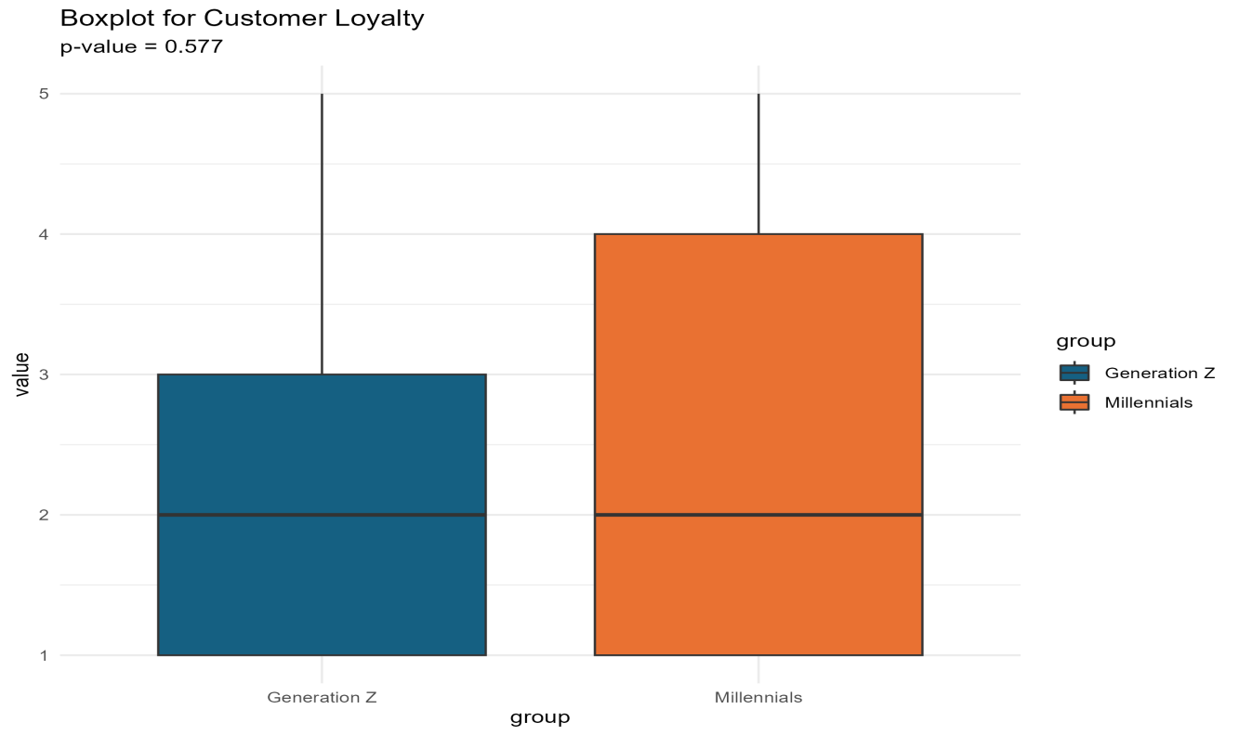

From the result in figure 5 above, according to (Wilcox, 2012) with a p value of 0.5775 we failed to reject our null hypothesis and concluded that there was no significance difference in brand loyalty between Generation Z and Millennial at a 95% significance level. The same test was also conducted on factors affecting brand loyalty at 95% significance level;

Figure 6

|  |  |  |
| --- | --- | --- |
| Factor | P-values | Statistic |
| Customer trust | 0.8218 | 630.5 |
| Customer Commitment | 0.7000 | 582.5 |
| Customer satisfaction | 0.8443 | 629.0 |
| Perceived quality | 0.6742 | 578.5 |
| Social media and influencers | 0.3947 | 543.5 |

The aforementioned table presents all the characteristics that impact brand loyalty and shows that there is no statistically significant difference in loyalty between Generation Z and Millennials as all P-values were greater than an alpha of (0.05). I therefore went further and examined whether there was a significant difference in the rate of switching between tech brands. I found that there was a high probability of Millennials shifting between tech brands as compared to Generation Z, with a p-value of 0.02—less than the alpha of 0.05—so I rejected my null hypothesis. I also looked at how much time was spent on social media, and with a p-value of 0.0001, I was able to reject the null hypothesis and come to the conclusion that, with a mean value of 6 hours, Generation Z spent more time on social media than Millennials.

## 6.2. Discussion

### 6.2.1. Findings:

I deduced from my created hypotheses that: There is no significant difference between Generation Z and Millennials in terms of overall brand loyalty. The situation varies, though, depending on the product—for example; Generation Z is very devoted to electronic products. Furthermore, there was no discernible variation in the mean ratings of the several independent variables, which included social media, customer trust, customer commitment, customer satisfaction, perceived product quality, and influencers influencing the dependent variable, brand loyalty. The conclusion that there is no statistically significant difference between Generation Z and Millennials was supported by this, since it confirmed the rejection of null hypotheses on brand loyalty and its limiting determinants. Millennials were found to be less devoted to electronic items than Generation Z, and because they spend more hours each day on social media, they were also found to be more vulnerable to its influence.

### 6.2.2. Limitations:

* The convenience sample used to collect the data may not accurately represent the entire population. Additional investigation is required to validate these results using a more varied sample.
* Furthermore, there are other numerous factors affecting brand loyalty including; race, Country’s GDP and industrialization levels in different economies among others and thus more research should be carried out on these factors for definite and concrete results.

# 7. Conclusion

## 7.1 Summary of Key Arguments

Based on previously published research, the study examined the disparities in brand loyalty between Millennials and Generation Z, offering explanations and counterarguments. According to the preliminary data study, Gen Z members are not inherently less loyal overall, even if they may show distinct patterns of commitment. The study also looked into how different the spectrum of factors was that affected brand loyalty, and it concluded that none of the factors differed significantly. In contrast to Millennials, Generation Z seems to be spending more time on social media when comparing the amount of time spent on it. Additionally, Generation Z also showed a higher level of brand loyalty towards technical brands.

## 7.2. Conclusion of the Thesis

The empirical study sheds light on the variations in brand loyalty across generations and shows that loyalty patterns are influenced by a range of factors, including social media, perceived product quality, customer satisfaction, customer trust, customer commitment, and influencers. Although it shows up in different ways, Generation Z's loyalty does not always differ from Millennials'.

## 7.3. Future Research

To have a better understanding of loyalty behaviors, future research may examine brand loyalty in different generations, look more closely at certain product categories, and employ bigger, more representative sample sizes. Furthermore, additional variables influencing brand loyalty may be included in later research.

# 8. Bibliography

## 8.1. References

Doe, J. (2020). *Understanding customer loyalty: Factors and strategies*. Academic Press.

Smith, J. (2022). *Brand loyalty beyond satisfaction: Understanding the multi-faceted drivers of consumer commitment*. Business Insights Press.

Johnson, L., & Brown, M. (2021). *The dynamics of brand loyalty: Beyond customer satisfaction*. Marketing Scholars Publishing.

Moorman, C., Deshpandé, R., & Zaltman, G. (1993). **The impact of market research on brand loyalty**. *Harvard Business Review Press*.

Brown, D., & Hayes, N. (2022). *Influencer marketing: Strategies for engaging digital natives*. Routledge.

Kim, A., & Ko, E. (2023). Interactive social media marketing and brand loyalty: The role of user engagement in Millennial and Gen Z consumers. *Journal of Interactive Marketing*, 58, 45-59. https://doi.org/10.1016/j.intmar.2023.01.003

Lee, J., & Li, X. (2023). The impact of social media following on brand loyalty among Millennials and Gen Z. *Marketing Research*, 35(2), 112-127. https://doi.org/10.1177/00222437221101234

Smith, M. (2021). *The digital consumer: Understanding Millennial and Gen Z brand loyalty in the age of social media*. Palgrave Macmillan.

Kotler, P., & Keller, K. L. (2012). *Marketing management* (14th ed.). Pearson.

Kundu, S. & Datta, S.K. (2015). Impact of trust on the relationship of e-service quality and customer satisfaction, EuroMed Journal of Business, 10 (1), 35–46. https://doi. org/10.1108/EMJB-10-2013-0053

Paquette, S. (2006). Customer Knowledge Management. Idea Group Inc.: 4-7, http://www3.fis.utoronto.ca

/phd/paquette/docs/Paquette%20-%20Customer%20Knowledge%20Management.pdf, (20.05.2010.).

Fromm, J., & Garton, C. (2013). *Marketing to millennials: Reach the largest and most important generation of consumers ever*. Per Capita Publishing.

Koulopoulos, T., & Keldsen, D. (2014). *The Gen Z effect: The six forces shaping the future of business*. Bibliomotion.

Melnyk, L. (2020). *Different loyalty expressions: How brand loyalty is changing in the age of Gen Z*. Journal of Consumer Research, 47(5), 1030-1045.

White, J. E. (2018). *The next generation: How Generation Z is shaping the future of brands*. Baker Books.

Ajzen, I. (1991). *The theory of planned behavior*. *Organizational Behavior and Human Decision Processes*, 50(2), 179-211.

Wilcox, R. R. (2012). *Nonparametric statistics for the behavioral sciences* (2nd ed.). Sage Publications.

Twenge, J. M. (2017). *iGen: Why today's super-connected kids are growing up less rebellious, more tolerant, less happy—and completely unprepared for adulthood* (1st ed.). Atria Books.